**Quantifying surface water-groundwater exchange using temperature profile inverse modelling at a riparian wetland**

Jack Lange

Submitted under the supervision of Crystal Ng to the University Honors Program at the University of Minnesota-Twin Cities in partial fulfillment of the requirements for the degree of Bachelor Science, *summa cum laude* in Earth Sciences.

May 2018

**Acknowledgments**

**Abstract**

Second Creek is wild rice stream located on the Iron Range in northeast Minnesota that has been impacted by mining pollution. In order to understand how mining-derived sulfate affects biogeochemical cycling at Second Creek, surface water-ground water exchange must be quantified, because it controls geochemical gradients in the sediment. We employed inverse temperature profile modeling to estimate hyporheic flux at the site. Temperature profile methods have been most widely applied in streambeds with sediments that are sand-size and greater, and support relatively high flux magnitudes. In contrast, the Second Creek study site is a riparian wetland where low hyporheic flux is expected. Streambed temperature profiles were measured at three locations across a transect of the site spanning from the main stream channel to the flanking wetland area over the summer of 2016.  The data were collected using low-cost, open-source vertical temperature profilers and “ALog” data loggers. The USGS model 1DTempPro was applied to the temperature data, along with co-located head data at each location to estimate hydraulic conductivity across the transect. The sediment thermal parameters used in the model were constrained based on the sediment bulk density, which is strongly controlled by organic content. The estimated hydraulic conductivity values were applied to the measured head gradients to generate time series of hyporheic flux time at the transect for the summer. Results showed spatial variability in both hydraulic properties and hyporheic flux. Across the transect, flux was upward toward the surface water for nearly the entire summer, though the magnitude of the flux varied dynamically in response to variable weather conditions and one flux reversal occurred following a strong late-summer storm event.

Table of Contents

Introduction

**Introduction**

The impact of mining on water quality in Minnesota’s iron range is a contentious topic. Elevated sulfate concentrations are present in the lakes and streams of the area due to runoff from mining operations. (cite) Concern over the impact of elevated sulfate levels in the surface water will negatively impact manoomin (wild rice) growth has prompted in depth studies of geochemical processes in aquatic ecosystems ((Pastor et al. 2017; Myrbo et al., in review, a; Myrbo et al., in review, b, ng et al, yourd et al). This study is a continuation of the work done by (yourd + ng) , who investigated the effect of interaction between groundwater and surface water in the hyporheic zone. This study expands on work done by ng and yourd to quantify the magnitude of vertical hydraulic flux in the hyporheic zone. The chemical gradient in the hyporheic zone where manoomin is rooted is controlled by hyporheic flux because the surfacewater and groundwater have unique chemical composition.(cite for different chemical composition)(cite for controlling gradient).

To address the need for better quantification of flux stated in (yourd), the inverse temperature profile modelling technique was applied to estimate vertical flux over the summer of 2016. This method uses temperature as a tracer to track groundwater-surfacewater exchange. temperature of surface water varies diurnally as it is heats u during the day and cools over night, while the groundwater temperature is relatively constant. The 1D temp pro software is used to generate synthetic temperature profiles based on this boundary conditions, then compare d to observation and iterate…(see usgs 2013. To inform the model, sediment properties were estimated b hand. Once the hydraulic parameters were estimated the q ts cvan be generated

**Methods**

Darcy’s law describes the movement of fluid through a porous media. It is presented here

(explain variables). The quantity of interest in this study is q, the vertical hydraulic flux. The head gradient, dh/hz, is calculated from the piezometer and stream gauge measurments. As is the classic problem in hydrogeology, the hydraulic conductivity, K, is the most challenging parameter to pin down. The inverse temperature profiling method is employed to estimate K.

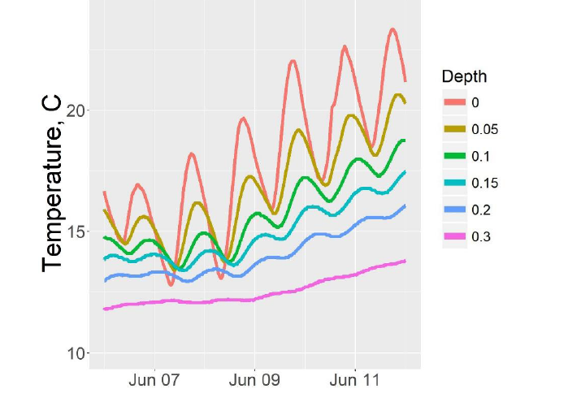

The Inverse Temperature Profile Modeling method uses temperature as a tracer for streambed flux. 1D heat transport in the streambed is predicted by the heat-transport equation. A parameter estimation routine can be used to estimate quantities on interest where the temperature profile is measured. 1DTempPro supports the estimation of one parameter (ELABORATE ASSUMPTIONS) The heat transport equation can be used to generate a synthetic temperature profile, which is adjusted by adjusting hydraulic conductivity to amtch the observed prodfile. The forward model uses the top and bottom temperature probes , and a frwards difference scheme to generate the synthetic profile. Then the parameters are adjusted (K) to match the observed and estimated profiles. More detailed explanation of the model, and previous temperature profile modelling work can be found in (2008), Anderson (2005), and Constantz and Stonestrom (2003).”(usgs 2013)

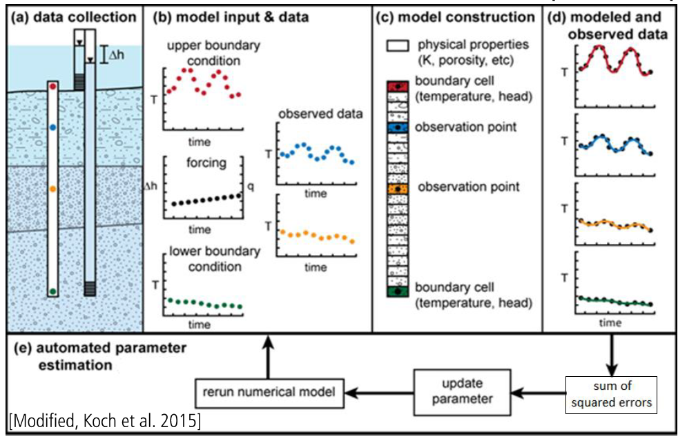

**Data Collection**

To inform the inverse model, temperature and head data ta was collected during the summer of 2016.

The temperature probes were 1 inch PVC tubing with 6 thermistors attached. The probes were inserted into the stream or wetland sediment such that the top thermistor was approximately at the sediment-water interface, and the bottom thermistor was located at approximately 30-40cm depth below the sediment-water interface, with most sensors clustered within the top10 cm, which corresponds to the wild rice root zone. (yourd). Temperature readings were logged at 10 to 15 minute intervals to capture diurnal and seasonal temperature variability at the site. Two probes collected data from June to August and one collected data from June to October.

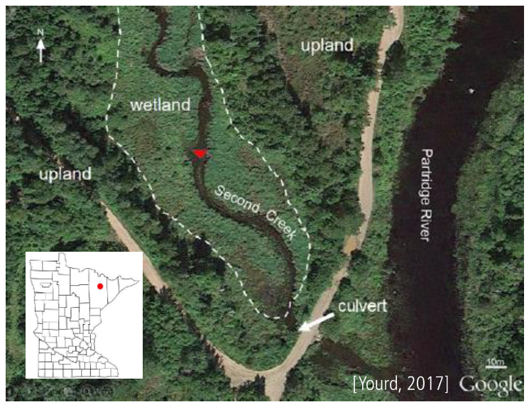The location of the probes is indicated on the map below.

Show location of probes

Head data was collected using three piezometers and a stream gauge. The piezometers and temperature probes were collocated. Pressure transducers in each piezometer and the stream gauge collected pressure data for the entire summer. The data loggers used in this study were low cost, open source loggers developed by Northern Widget LLC. (cite)

One gap in the stream gauge data exists from 7/25/16 to 8/1/16. The stream gauge went dry during this period. The gauge was relocated in the stream channel during field work on 8/1/2016.

-something about how head TS were claculated

The elevation of the transducers and stream gauge were surveyed 10/1/16. The elevation of the stream gauge before it was moved on 8/1/16 was not measured so a correction factor was applied to the data from the first half of summer. The method of correction is discussed in the results and conclusions section.

Atmospheric pressure was provided by \_\_\_\_\_\_\_ (Crystal, who provided this data, I recall that it was a state of MN study?) Site precipitation data was acquired from the nearest weather station located in Embarrass, MN 10 miles north of the site. (cite)

**Thermal parameter estimation**

To complete the forward modelling, 1DTempPro requires information about the thermal properties of the streambed. Specifically, the sediment thermal conductivity and the saturated heat capacity. The inverse temperature profile modelling approach has primarily been applied in settings where the thermal parameters are relatively insensitive and invariant. (cite) For example, in rocky and sandy stream beds the thermal parameters can be roughly estimated as those of siliclastic minerals. The sediment at second Creek is more complex. The streambed is composed of a mixture of siliclastic and heavily organic matter. Furthermore, the sediment at Second Creek is extremely heterogeneous, as show in the soil samples in figure \_\_.

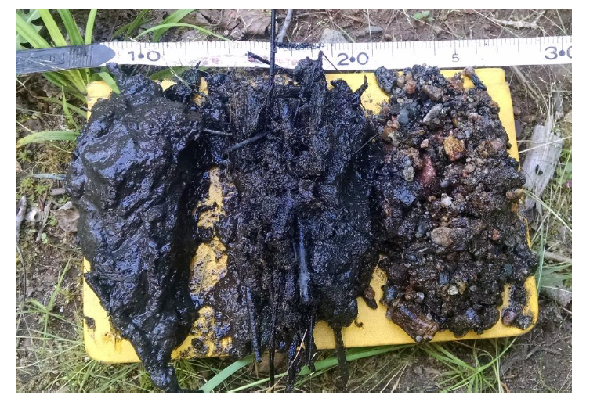

Yourd 2017

In order to make a reasonable estimation of the thermal parameters of the site sediment some simplifying assumptions were required. The first simplifying assumption was that the sediment was composed entirely of two endmembers, siliclastic sediment and soil organic matter. The second simplifying assumption is that the streambed is homogenous at all the TP locations. Both of these assumptions are be justified during model sensitivity analysis in the results and conclusions section.

The percentage, by mass, of SOM and siliclastic minerals present was calculated using the following expression

Dry bulk density = density sili \* percent sili + density SOM \* percent SOM

The value for dry Bulk density was established in (mybro). This calculation resulted in a distribution of 90SOM and 10% siliclastic. High organic content is expected at Second creek, and this value is supported by the images above where many of the sediment samples appear to contain entirely SOM, however in order to extend to our second assumption (heterogeneity). An 80-20 split was used to more accutatley capture heterogeneity that could be present. Especially because we don’t know where the dry bulk density was collected.

Using the fraction of SOM and siliclastic, the thermal properties of the streambedk can be estimated by the method in Farouki

Sediment Thermal conductivity

Saturated heat capacity

This method bounds the thermal parameter with an upper and lower limit. The validity of the estimated thermal parameters will be discussed in the sensitivity analysis portion of the results and conclusions section.

The last parameter needed for the forwards model is dispersivity. This parameter depends on the scale of the problem. REFRENCE ABOUT IT BEING NEGLIDGIBLE AT SMALL SCALE, REFRENCE ABOUT IT BEING IN WHAT RANGE FOR FIELD SUTDIES

-note that there is uncertainty here

So, with the model informed and data in place here are the results

**Results and Conclusions**

|  |  |
| --- | --- |
| **Location** | **Hydraulic conductivity, m/d** |
| West wetland | 0.07 |
| Stream west | 0.04 |
| Stream center | 0.18 |

The following estimates for Hydraulic conductivity at each temperature probe(table \_\_\_) were obtbained using the input parameters presented in table \_\_\_\_\_\_

Table of parameters:

These values were used with equation (darcy) to generate time series of vertical hydraulic flux at each temp probe. Figure () The time series are plotted with precipitation data to see the relationship between them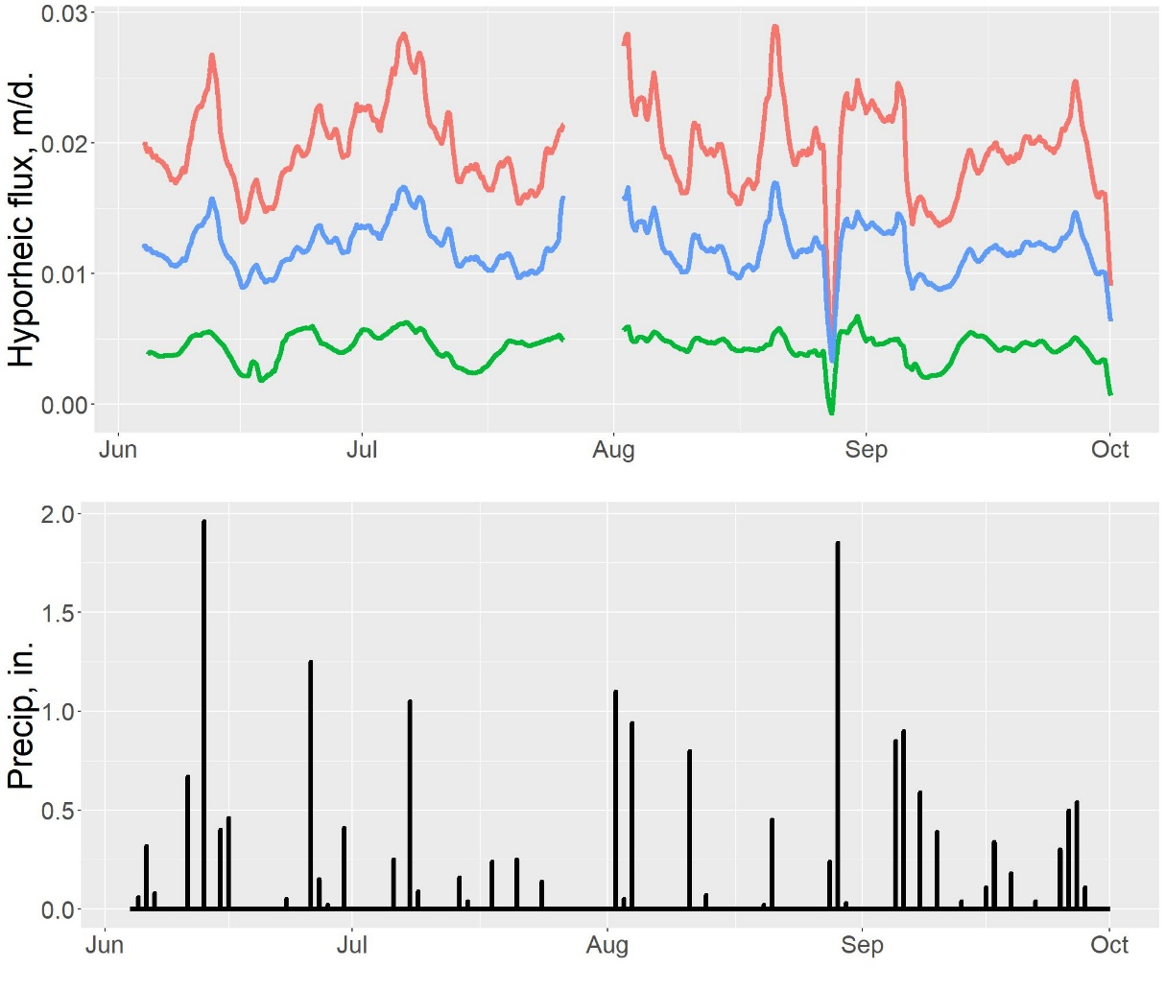

Caption,key

The highest hydraulic conductivity and flux occur in the west wetland, followed by the stream center and the west stream channel. This is counterintuitive, as we originally expected the wetland area to have the smallest flux. There are several possible explanations for this discrepancy. First, the site sediment is highly heterogeneous this suggests that the hydraulic flux is equally heterogeneous. It is possible that the wetland temperature probe was placed in a region that facilitated higher flux while the stream probes were located in lower flux regions. Another possible explanation is that flow at the wetland probe has a significant horizontal component, violating the assumption the hydraulic flux is entirely in the vertical direction. This explanation has merit because the head in the wetland sediment was consistently higher than the head at the base of the stream (more than elevation difference?), which suggests that the water in the wetland sediment could be flowing more towards the stream base than upwards (see site conceptual model)

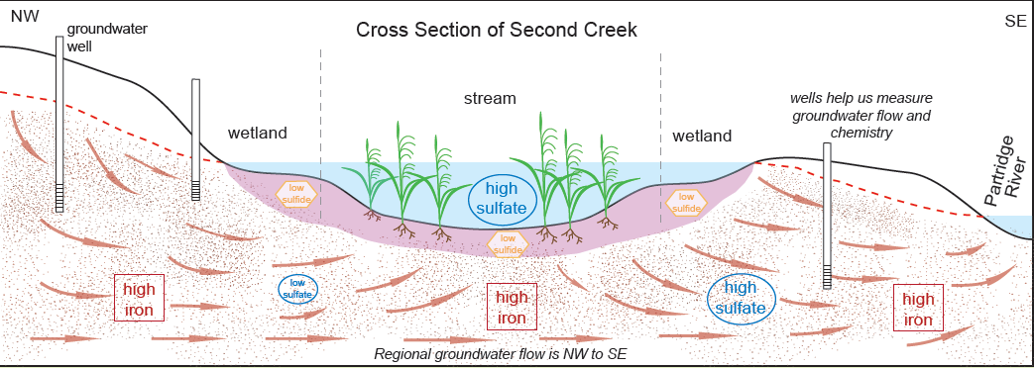

The direction of vertical flux across the transect is upwards for the entire summer except for one brief flux reversal in late August. The magnitude of vertical hydraulic flux over the summer is variable. The flux magnitude appears to be linked with precipitation. Major changes in flux magnitude occur following large rain events. Sometimes these rain events increase the upward flux magnitude, indicating that the rainfall initiates a base flow event. In other cases, rain events are followed by decreased upwards flux, or even downwards flux, indicating that the rainfall runs off into the surface water quickly. A possible explanation for this discrepancy is that the precipitation data was collected from a weather station that is 10 miles north of the study site, so it is possible that during these storm events the stream and the weather station don’t experience the same meteorological conditions. The streams response to the storms could be related to the proximity of the storm to the stream. For example, a distant storm would be more likely to trigger a large, prolonged base flow event, and a storm that occurs on second creek could cause a rapid rise in surface water levels, resulting in an immediate decrease in upwards flux, and in the case of an extreme storm, downwards flux. Another possible explanation for the varied response to storm events could be seasonal changes in vegetation in the region. More study is required to determine if these explanations have merit.

The validity of the estimate hydraulic conductivity is explored in the following section.

**Sensitivity analysis**

To evaluate the quality of the model results and dependencies of the hand estimated parameters… The inverse model was run over the range of parametersestimated earlier. The inverse model was run as each parameter was varied over its range,while the rest of the parameters were held constant at a middling value in their range. The resulting value of K for each of these model runs is presented in figure (). The goodness of fit between the model’s final synthetic profile and theobserved temperature profile is qualitatively demonstrated by the size of each point

C:\SecondCreekGit\Presentations and figures\North Central GSA poster\q_smoothed.tif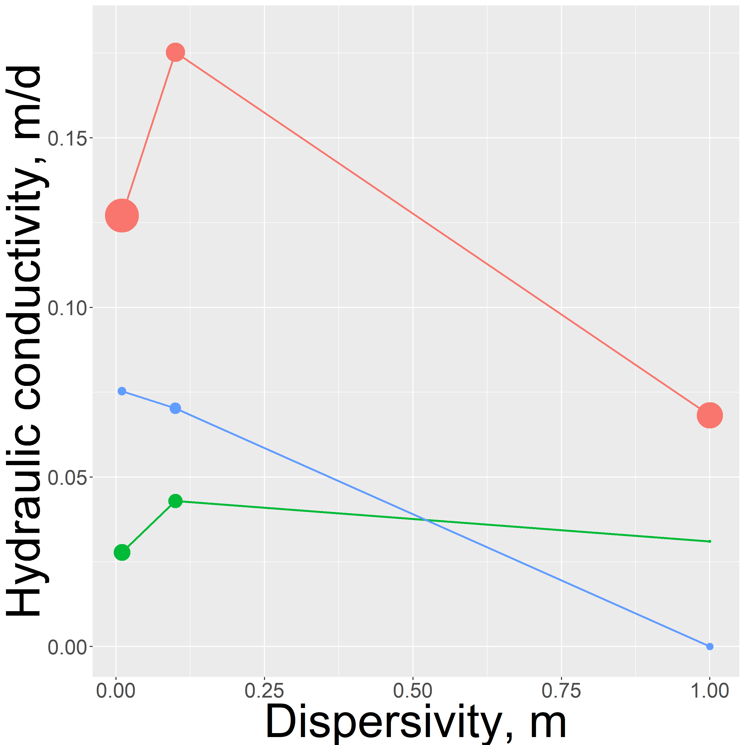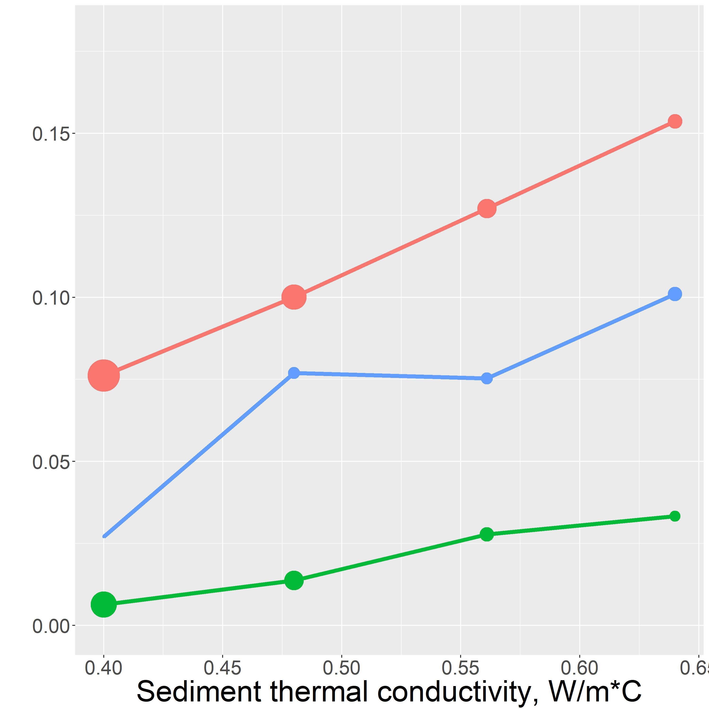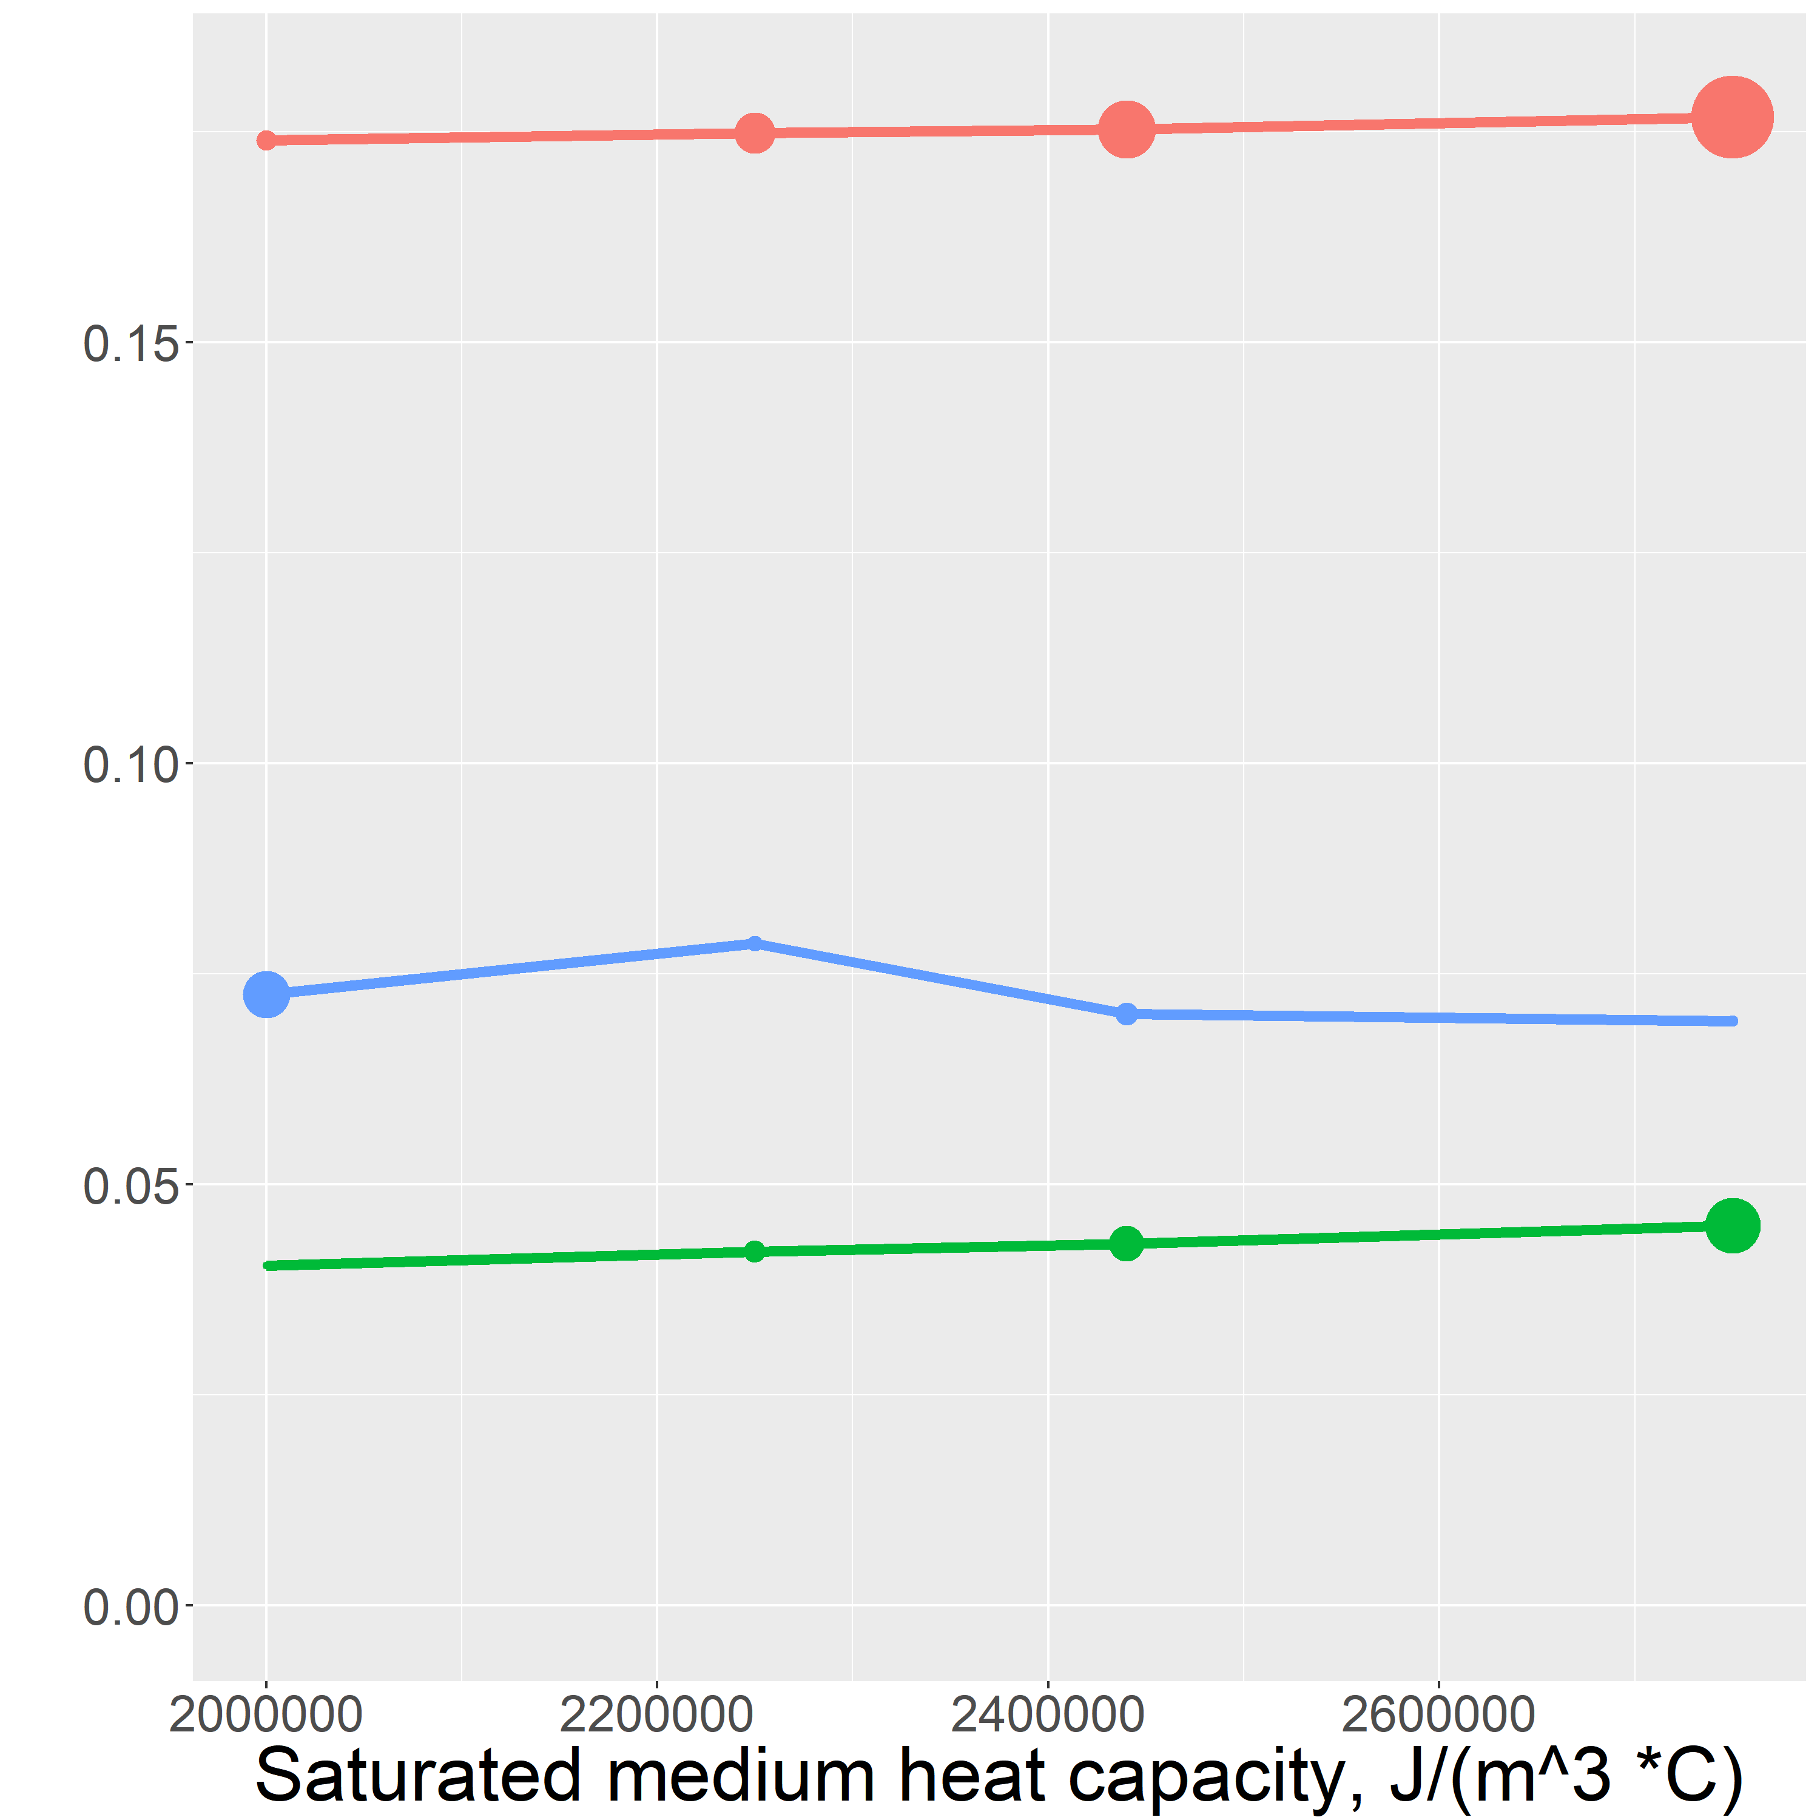

The goodness of fit between the model’s final synthetic profile and the observed temperature profile is qualitatively demonstrated by the size of each point. (add a model failure arrow)

Dispersity sensitivitvity

Unlike the other hand estimated parameters, the inverse model is not linearly sensitive to the value of dispersity. This nonlinearity is caused by the dependence of dispersivity on flux magnitude,

Alpha = vD

Dispersitivity can vary by orders of magniture depending on the scale of the are a considered. These made dispersivity the hardes parameter to hand estimate. Using a value of 0.1 m gave the best quality of fit for the inverse model.

Thermal conductivity

The dependency of the inverse model results on thermal conductivity is a linearly increase over the range of values.

Saturated heat capacity

The most obvious conclusion from this analysis is that the saturated heat capacity is the least sensitive paramaeter of the hand estimated parameters. The saturated heat capacity calue that gave the best fit at all of the temperature probes is 2.25 \* 10^6 J/(m^3 \* C) which is the saturated heat capacity of a \_% silicate \_% organic matter \_% water mixture , consistent with the conditions at the site.

The final parameter values are show in table \_

CORRECTIONS!!! (using first half of summer and second gave same conclusion for TPA)

Generally, the variation in results is low elative to the possible variability of K, furthermore it is good that the general trend is maintained

Resummarize results

The results of this work have been used with reactive transport modeling to investigate the influence of hyporheic flux on biogeochemical cycling at Second Creek. [ng presentation ]

The results could be expanded and improved by doing unique sediment parameter calibration for each temperature probe. This includes, porosity as well as thermal parameters. This could be achieved by careful sediment sampling and analysis in the field, or by employing a multiple parameter estimation routine such as PEST(citation).

This USGS software has two citations associated with it.

1. The report citation is for the original report or article documenting the underlying theory, methods, instructions, and (or) applications at the time the initial version of the software was released. This digital object identifier (DOI) is for the report.
2. The software release citation is for the software/code itself (now referred to by USGS as a "Software Release") and references a specific version of the code and associated release date. This DOI links to the code.
3. **Farouki, O., 1961.** *Thermal properties of soils*. United States Army Corps of Engineers Cold Regions Research and Engineering Laboratory.; **Hayashi, M. & Rosenberry, D.O., 2002.** Effects of Groundwater Exchange on the Hydrology and Ecology on Surface Water. *Groundwater*.; **Healy, R.W., and A.D. Ronan. 1996.** Documentation of computer program VS2DH for simulation of energy transport in variably saturated porous media – modification of the U.S. Geological Survey’s computer program VS2DT. *U.S. Geological Survey Water-Resources Investigations Report*.; **Koch et al. 2015.,** 1DTempPro V2: New Features for Inferring Groundwater/Surface-Water Exchange*, Groundwater*.; **Kurtz, A.M. et al., 2007.** The importance of subsurface geology for water source and vegetation communities in Cherokee Marsh, Wisconsin. *Wetlands*.; **Mybro, A., 2013**. Wild Rice Sulfate Standard Field Surveys 2011, 2012, 2013: Final Report. *University of Minnesota*.; **Yourd, A., 2017.** *Using reactive transport modeling to link hydrologic flux and root zone geochemistry at Second Creek, a sulfate enriched wild rice stream in northeastern Minnesota, Masters Thesis, University of Minnesota*.; **Wickert, A 2014.** The Alog: inexpensive, Open Source, Automated Data Collection In the Field.  *The Bulletin of the Ecological Society of America* **Zheng, C. & Bennett, G., 1995.** *Applied Contaminant Transport Modeling .* John Wiley & Sons.